https://www.youtube.com/watch?v=dZ3NcosYvrI&list=PLcFnxKjhr7FpJI7wmdkIkCBP_-3BfKt08&index=12
ODATA connection address : https://services.odata.org/Northwind/Northwind.svc
When we upload wsdl file
service and endpoint get auto fetch
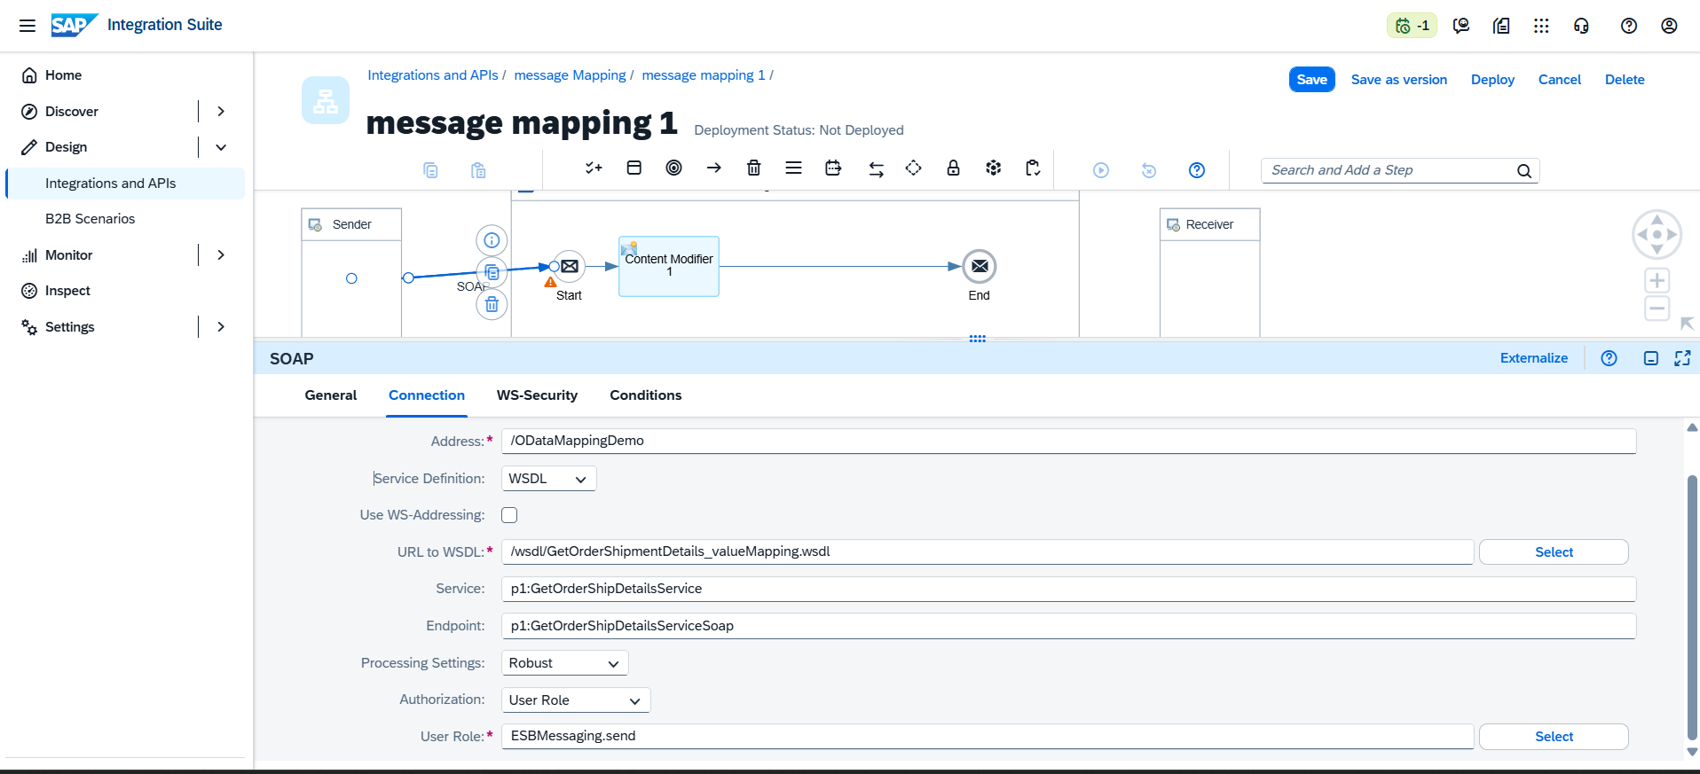
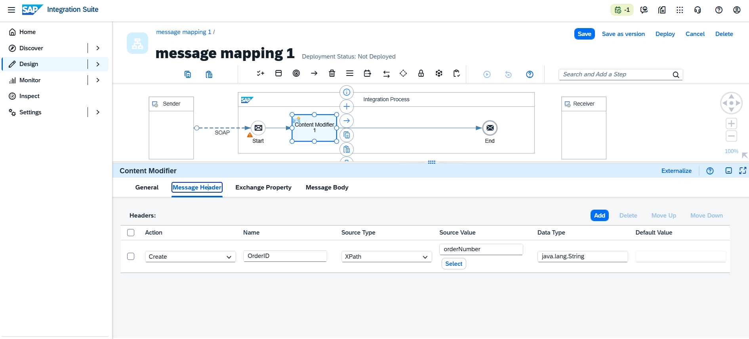

ODATA connection address : https://services.odata.org/Northwind/Northwind.svc
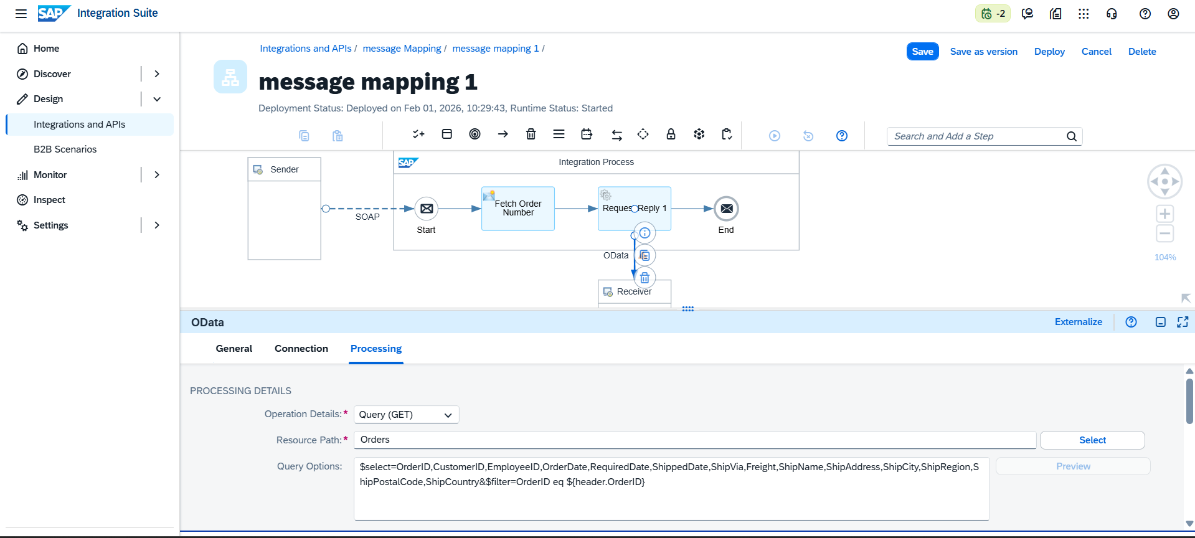

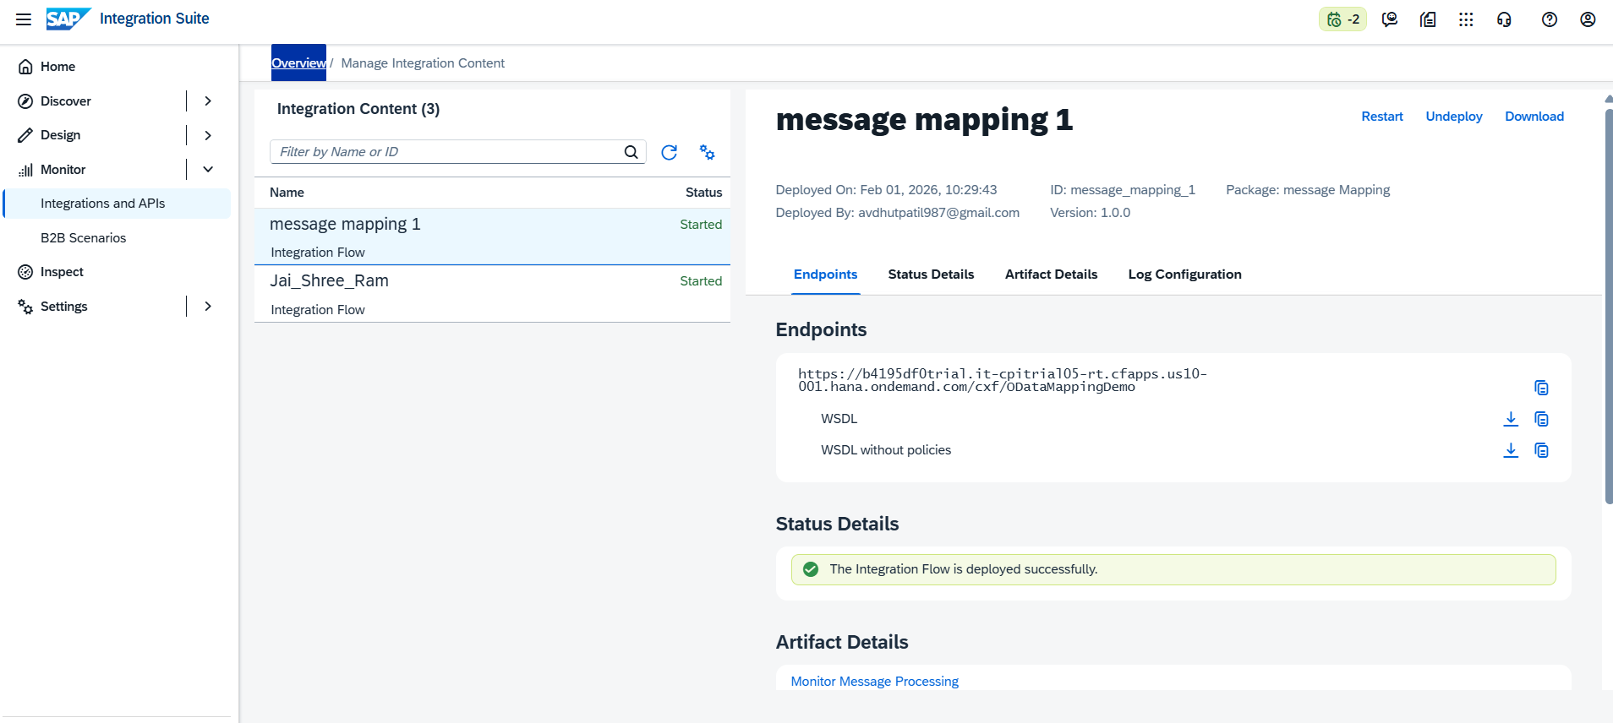
Copy wsdl file
go to soap ui
Copy service key and password
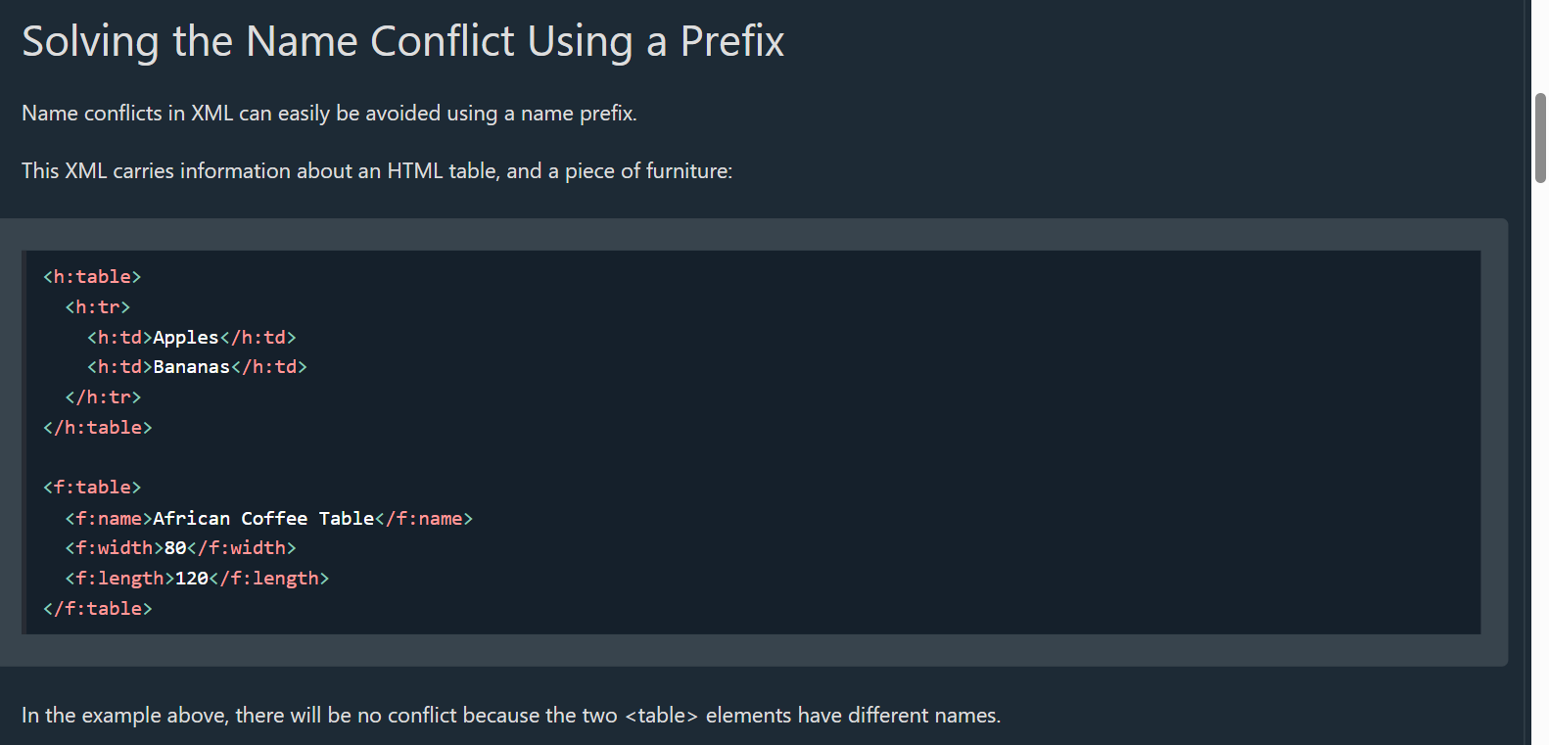

Sure 👍 continuing SAP CPI learning — point-wise, crisp & interview-ready.

🔹 SOAP Adapter – Full Form
SOAP = Simple Object Access Protocol

🔹 What is SOAP Adapter in SAP CPI?
SAP Integration Suite provides a SOAP Adapter to enable SOAP-based message exchange between systems using WSDL-defined web services.
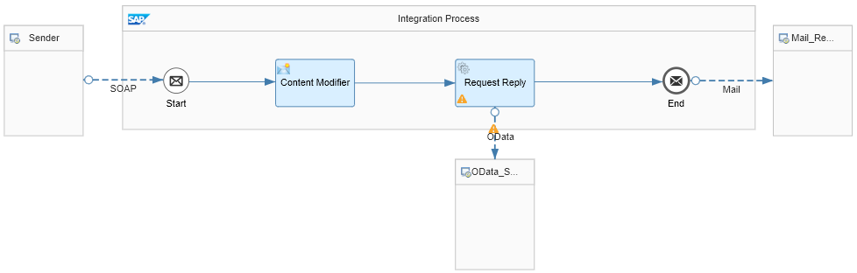
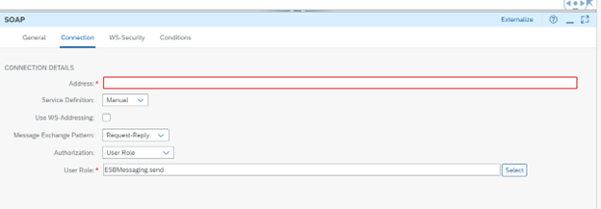
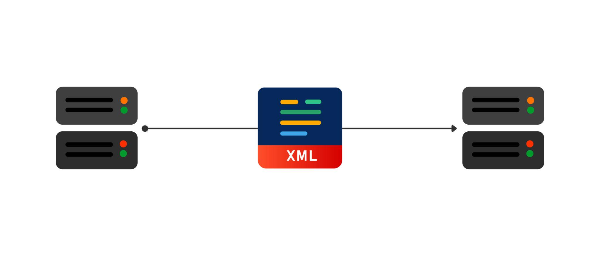

🔹 Use of SOAP Adapter (Why we use it)
- To send or receive SOAP messages
- To integrate with legacy or enterprise systems
- When systems expose SOAP Web Services (WSDL)
- Supports synchronous & asynchronous communication
- Common in SAP ↔ SAP and SAP ↔ Non-SAP integrations

🔹 Where SOAP Adapter is Used
- SAP ECC / S4HANA
- Third-party ERP or legacy systems
- Government / Banking systems (still SOAP heavy)
- Enterprise integrations needing strict contracts

🔹 Key Features
- Uses WSDL for service definition
- Supports SOAP 1.1 & SOAP 1.2
- Built-in error handling (SOAP Faults)
- Supports WS-Security
  - Username/Password
  - Certificates
- Works with XML payloads

🔹 SOAP Adapter vs REST Adapter (Quick)
SOAP Adapter | REST Adapter
XML only | JSON / XML
WSDL based | OpenAPI / URL based
Heavy & strict | Lightweight
Legacy systems | Modern apps

🔹 Interview One-Liner 💡
SOAP Adapter in SAP CPI is used to integrate systems using SOAP web services based on WSDL with secure and contract-based communication.
If you want next 👉
- SOAP Adapter configuration steps
- Real-time example
- SOAP vs REST deep interview Qs
Just tell me 👌

